**Robotic Operating systems and robot simulations**

Name : Girish S

Roll no: AM.EN.U4AIE22044

● Download and install the turtlesim package

○ Open a terminal and start the roscore  
*roscore*○ Open another terminal and type  
*sudo apt-get install ros-$(rosversion -d)-turtlesim*○ Run turtlesim

*rosrun turtlesim turtlesim_node*○ Open another terminal and type  
*rosrun turtlesim turtle_teleop_key*

➢ Use the keypad arrow keys to move the turtle around and  
check how the data is getting published in **/cmd_vel** topic

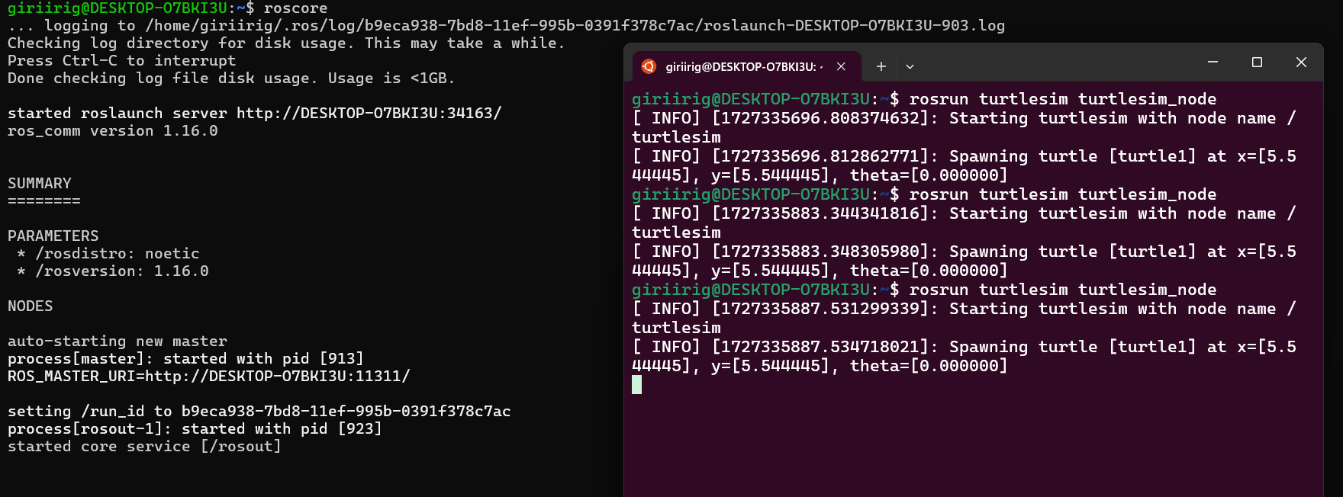

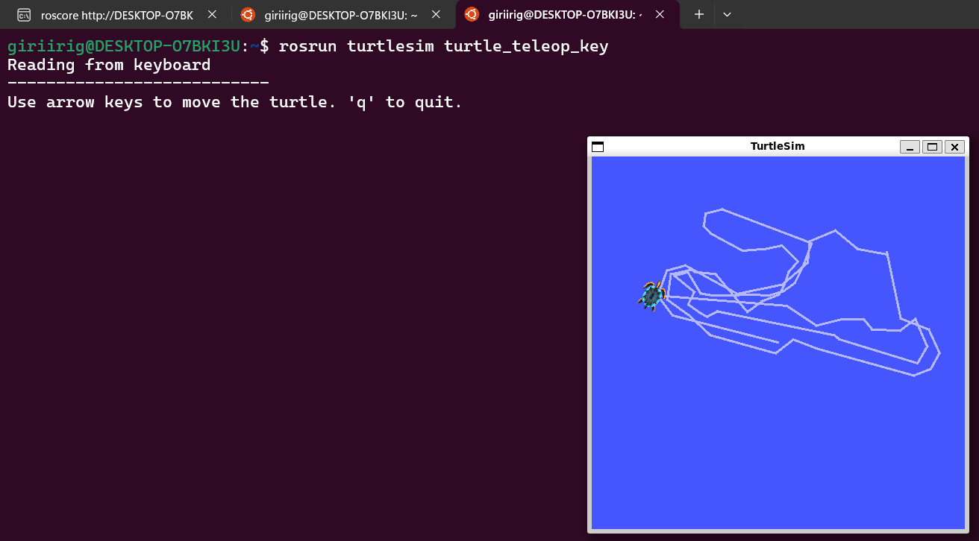

**Catkin workspace setup + publisher and subscriber :**

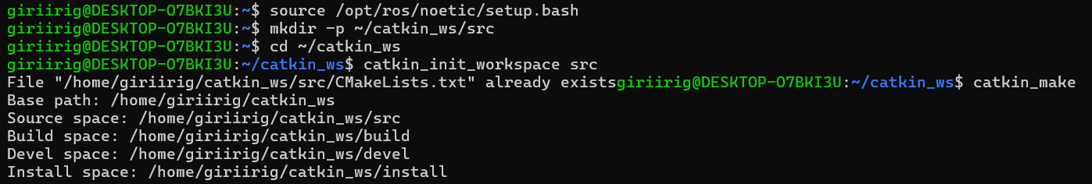

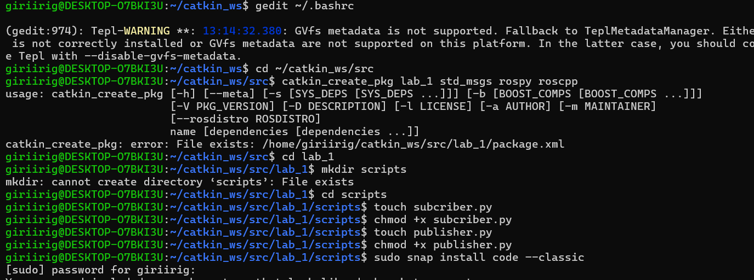

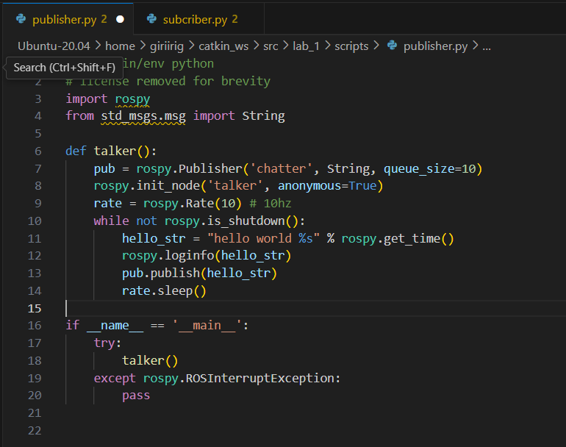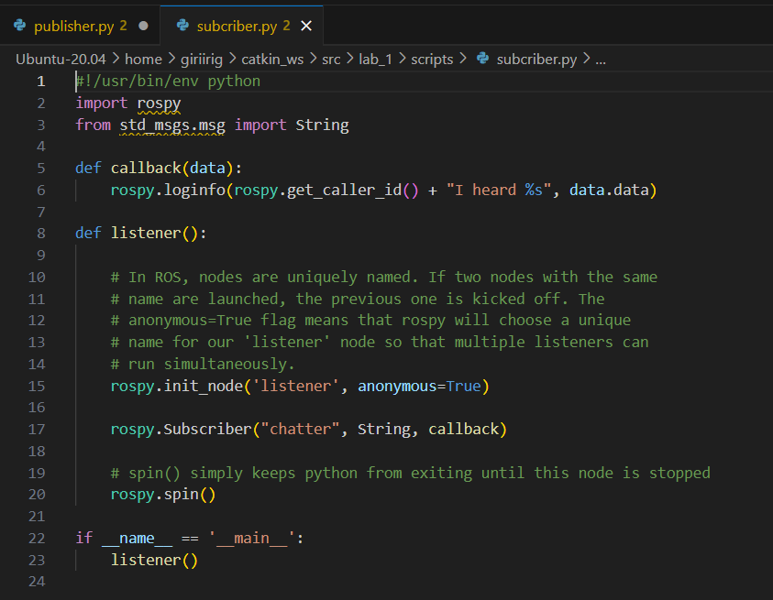

**Output (publisher.py) :**

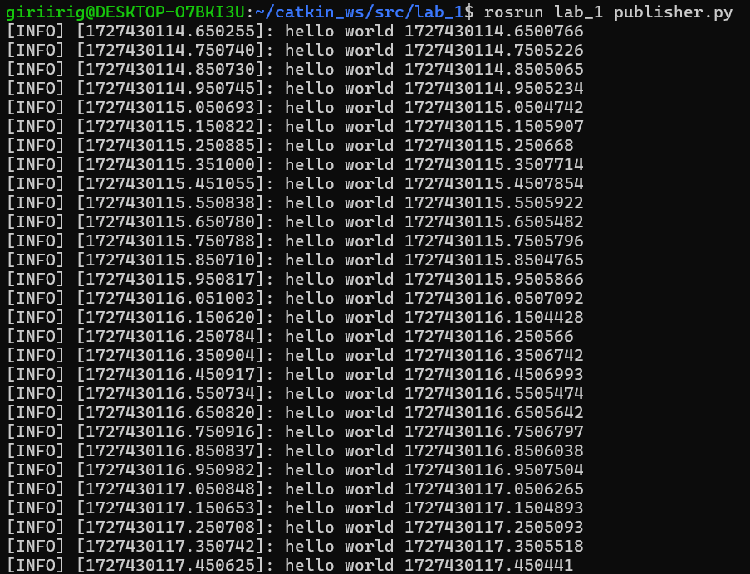

**Output (publisher.py) :**

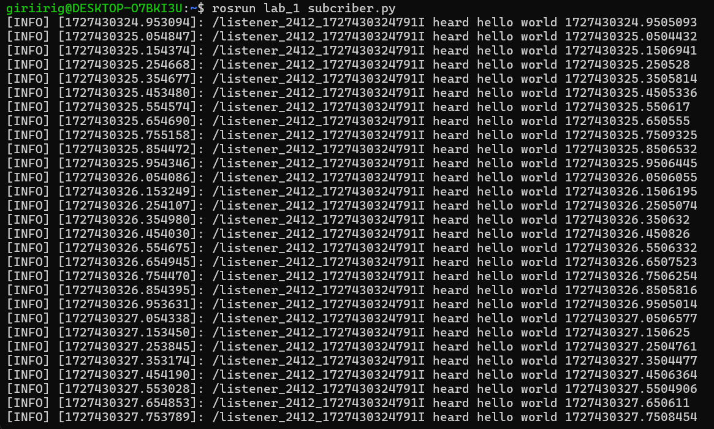

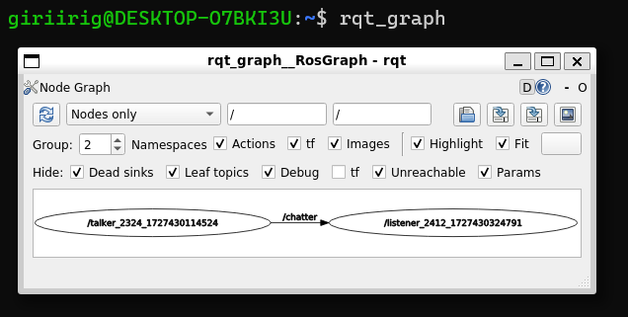



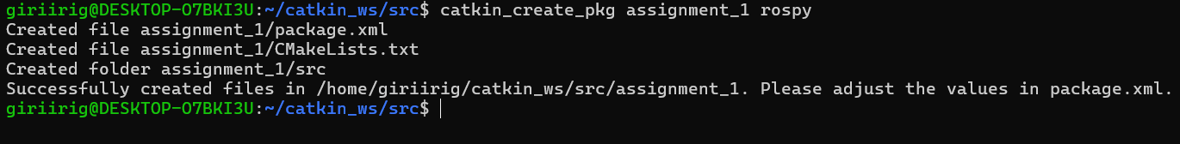

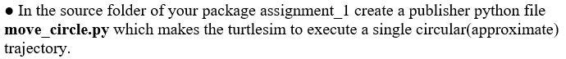

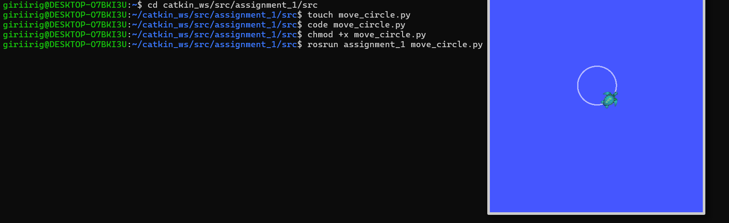

Code :

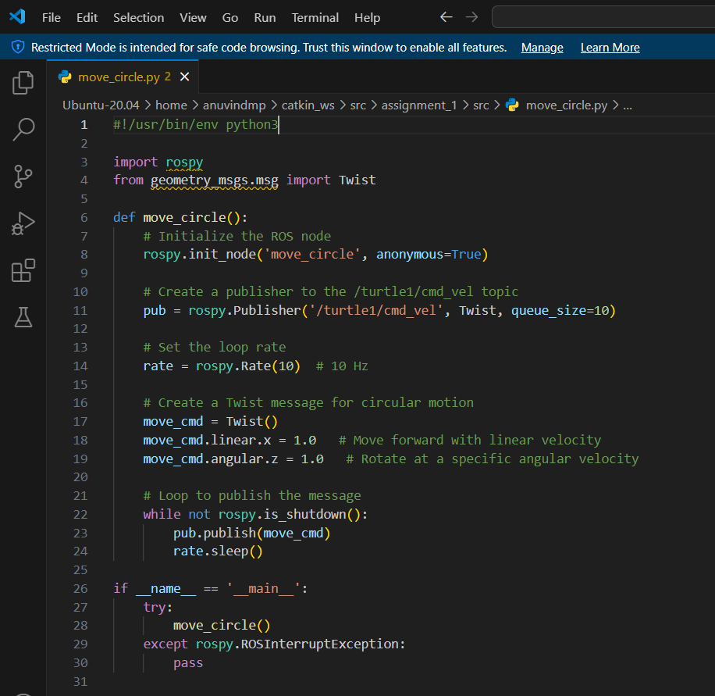

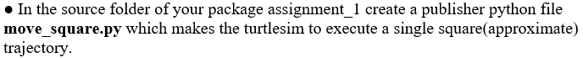

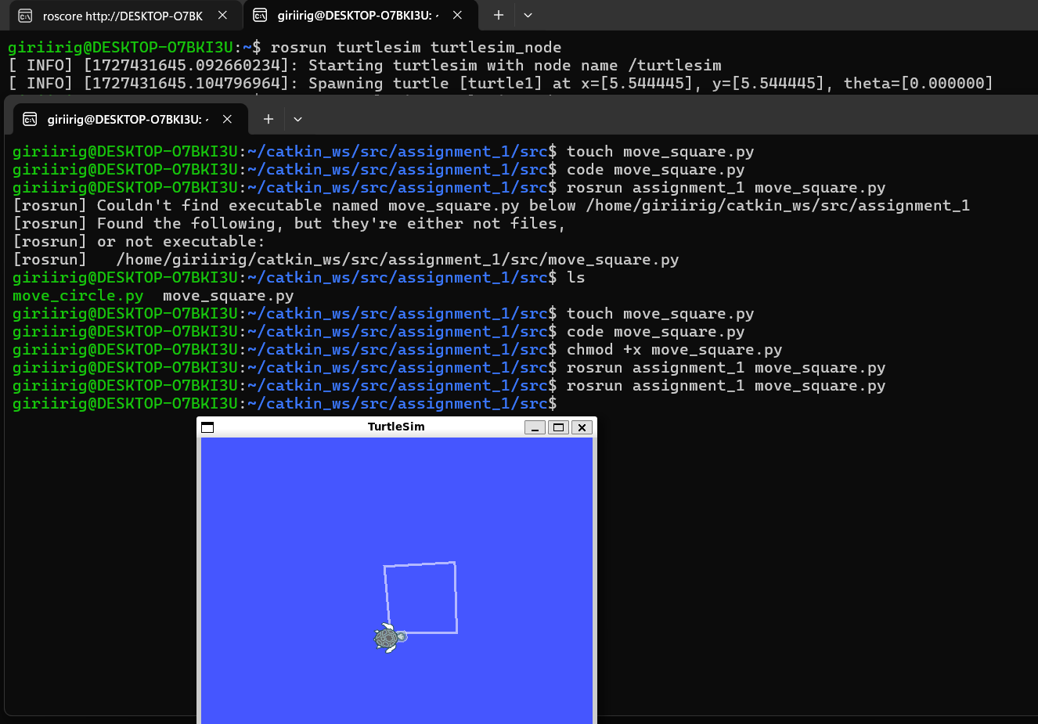

Code :

